Civil war in Liberia

UNSC Resolution: | 788
Date of adoption: | 19-Nov-1992
Operative paragraph: | 6
Demand number: | 788,0611

Sarah-Myriam Martin-Brûlé

Wording of demand

respect and implement the cease-fire and the various accords of the peace process, including the Yamoussoukro IV Accord of 30 October 1991, and the Final Communiqué of the Informal Consultative Group Meeting of ECOWAS Committee of Five on Liberia, issued at Geneva on 7 April 1992, to which they themselves have agreed

List of addressees of the demand

Government of Liberia, National Patriotic Front of Liberia, United Liberation Movement of Liberia for Democracy

Short-term compliance

Description of the addressee(s)’ conduct

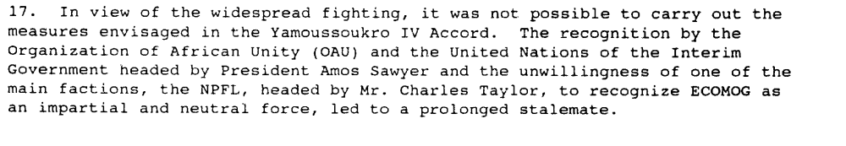

(…) Abuja in November 1992, where a call was once again made for a cease-fire, combined with a land, sea and air embargo against the NPFL. Taylor accepted, and then broke this latest cease-fire, resulting in Nigerian aircraft carrying out Operation 120 Hours — a sustained bombardment against his forces. This, in effect, exhausted regional initiatives, and led to an appeal by ECOWAS to both the OAU and the UN Security Council for assistance.

Hutchful, Eboe. “The ECOMOG Experience with Peacekeeping in West Africa”, Monograph No.36 : Whither Peacekeeping in Africa? April 1999

http://www.issafrica.org/Pubs/Monographs/No36/ECOMOG.html

“On 20 November 1992, the NPFL released a conciliatory statement proposing the disarmament and encampment of all factions in Liberia, and declaring that it was ready to abide by the Yamousoukro IV decisions, under the supervision of UN forces, but not under the supervision of ECOMOG which it still considered to be a Nigerian invasion force.”

http://pdfserve.informaworld.com/58820_751319779_784169793.pdf

“Taylor, who had previously lobbied for a UN presence, released a ‘conciliatory’ statement declaring that his forces would implement the provisions of Yamoussoukro IV Accords. This however did little to end the fighting which continued until April 1993.”

Ero, Comfort. 1995. “ECOWAS and the Subregional Peacekeeping in Liberia”. Journal of Humanitarian Assistance.

http://jha.ac/1995/09/25/ecowas-and-the-subregional-peacekeeping-in-liberia/

Assessment

Short-term compliance
X No or marginal compliance (1) | Medium low compliance (2) | Medium high compliance (3) | Full or almost full compliance (4)

Considerations underlying the assessment

The groups did sign the agreements, participated in the peace negotiations, and officially supported the Accords. Yet as the above reports show, they neither respected nor implemented the agreements.

Medium-term compliance

Description of the addressee(s)’ conduct

“Another important element in the draft resolution related to the continuing flow of weapons into Liberia in violation of the arms embargo imposed by resolution 788
(1992). That proliferation of weapons not only complicated the prospects for disarmament but also compounded the problems of security and jeopardized the safety of
ECOMOG and UNOMIL personnel in the country. It was important that all Member
States abide by and comply with the embargo on deliveries of weapons and military
equipment to Liberia.”

Chapter 8, “Repertoire of the Security Council”
http://www.un.org/fr/sc/repertoire/93-95/CHAPTER%208/AFRICA/item%2005-%20Liberia.pdf

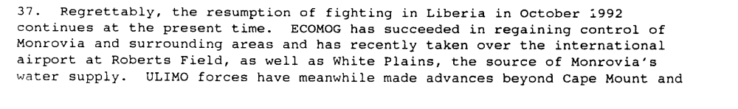

Report of the Secretary-General on the Question of Liberia, S/25402, 12 March 1993

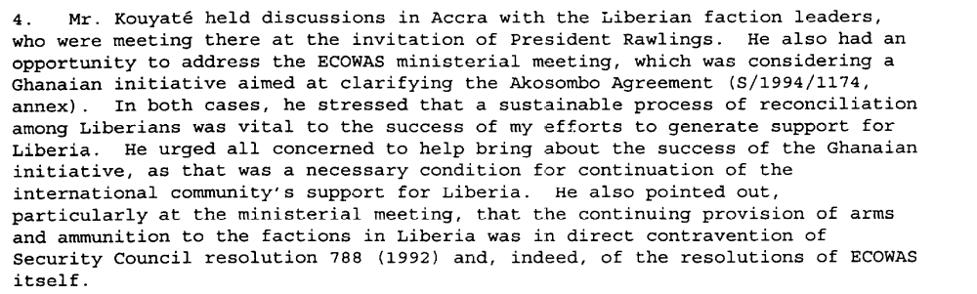

Eight Progress Report of the Secretary-General on the United Nations Observer Mission in Liberia, S/1995/9, 6 January 1995.

Assessment

Medium-term compliance
X No or marginal compliance (1) | Medium low compliance (2) | Medium high compliance (3) | Full or almost full compliance (4)

Considerations underlying the assessment

The demand addressees did not respect nor implement the cease-fire and the various accords of the peace process, including the Yamoussoukro IV Accord of 30 October 1991, and the Final Communiqué of the Informal Consultative Group Meeting of ECOWAS Committee of Five on Liberia, issued at Geneva on 7 April 1992, to which they themselves have agreed.

Depth of demand

Assessment

Level of depth of demand
Low depth of demand (1) | Medium depth of demand (2) | X High depth of demand (3)

Considerations underlying the assessment

Complying with this demand put the survival of the demand addressees at significant risk in the medium term for the following reasons:

The 1991 had not given the signatory parties sufficient stake in respecting the peace agreement. Moreover, in the years following the agreement, new rebel groups had formed. Some were created from “scratch”, while others were surrogate groups put in place by the signatory parties in order to continue their military activities and gain territory. Hence, while the addressees would officially comply with the cease-fire, they would organize parallel raids on villages in order to gain territory.

The NPFL came under so much pressure that in June 1993, the party considered that signing a new peace treaty would be advantageous. Yet the means were paradoxical to the end sought.

Ellis thus explains the stakes associated with the signing (and respect) of a peace agreement:

“The new armed faction, the United Liberation Movement for Democracy in Liberia (ULIMO) emerged, challenging Taylor’s military positions in south-western Iberia.
Africa at the Millenium, Bakut twash Bakut, Sagarika Dutt”
(…)
“Ecomog was putting powerful squeeze on the NPFL through a number of auxiliary or surrogate units, taking more of its most productive territory. Under pressure of this sort, Taylor was now for the first time seriously interested in a negotiated settlement. But the world had largely forgotten about the protracted war in Liberia. He needed to carry out an operation spectacular enough to capture international attention and enable him to secure international support for a ceasefire of which he was in great need.(….) By blaming massacre on the AFL, an Ecomog protégé, Taylor attracted a degree of sympathy for his plea for peace” (Ellis, 1999: 101).
(…)
“Although the Cotonou accord failed to bring lasting peace, collapsing within a few months, it did mark a significant development in the war in two respects. In the first palce, by providing for the dissolution of Sawyer’s Interim Government of National Unity and the installation of the Liberian National Transitional Government in which the NPFL and Ulimo were both represented, it gave the NPFL for the first time a stake in the official government of Liberia. This had the effect of gradually draining the NPFL into Monrovian politics. Second, the Cotonou agreement indirectly spawned new armed factions as the signatories to the accord, publicly committed to peace but privately still intent on war, supported the creation of surrogate groups, non-signatories who could continue hostilities. (Ellis 1999: 102)
(…)
“A year of peace had cost Taylor dearly since he had lost control of a large swathe of territory. He had been unable to make the transition he sought from warlord to politician.” (Ellis 1999:103)

Ellis, Stephen. 1999. The Mask of Anarchy. New York University Press.

Level of confidence about coding decisions

Level of confidence about coding decision
Extremely high | High | X Moderate

Comments to IPI (if any)

